**所有 Power BI 相關課程**

Contents

24.7.9 Introduction to Power BI 1

Transforming data 2

Visualizing Data 3

Filtering 4

24.7.18 Introduction to DAX in Power BI 6

Context in DAX formulas - CALCULATE() 6

Working with Dates - CALENDAR(), CALENDARAUTO(), DATEDIFF() 6

24.8.8 Data Visualization in Power BI 7

24.8.15 Case Study Analyzing Customer Churn in Power BI 8

# 24.7.9 Introduction to Power BI

* 下載Desktop Power BI

<https://www.microsoft.com/en-us/download/details.aspx?id=58494>

* Power BI Desktop is one of the main components of Power BI. It is a data analysis and report creation tool available on your local computer. It includes powerful features, like the Query Editor, and it's free to download. In this course, we'll use Power BI Desktop. This course will use the free version of Power BI, but there is a paid version called Power BI Pro available.
* Power BI Pro allows you to publish work on the Power BI cloud platform, called Power BI Service. It also allows you to collaborate with other Power BI users. Even though we're using the free version, everything you learn in this course will be applicable to the paid version.
* The second main component is Power BI service, the cloud version of Power BI. It can only be accessed with a Power BI Pro account. Reports can be edited in Power BI service, but not to the full extent as desktop. Instead, the main purpose of Power BI service is to share and distribute reports. You will commonly use Power BI Desktop to create a report and Power BI service to share that report.
* We can load data from >1 data source. 比如一個Power BI可以同時導入excel文件啊csv不同的去工作。比如下面截圖，這分別是兩個文件的文件名

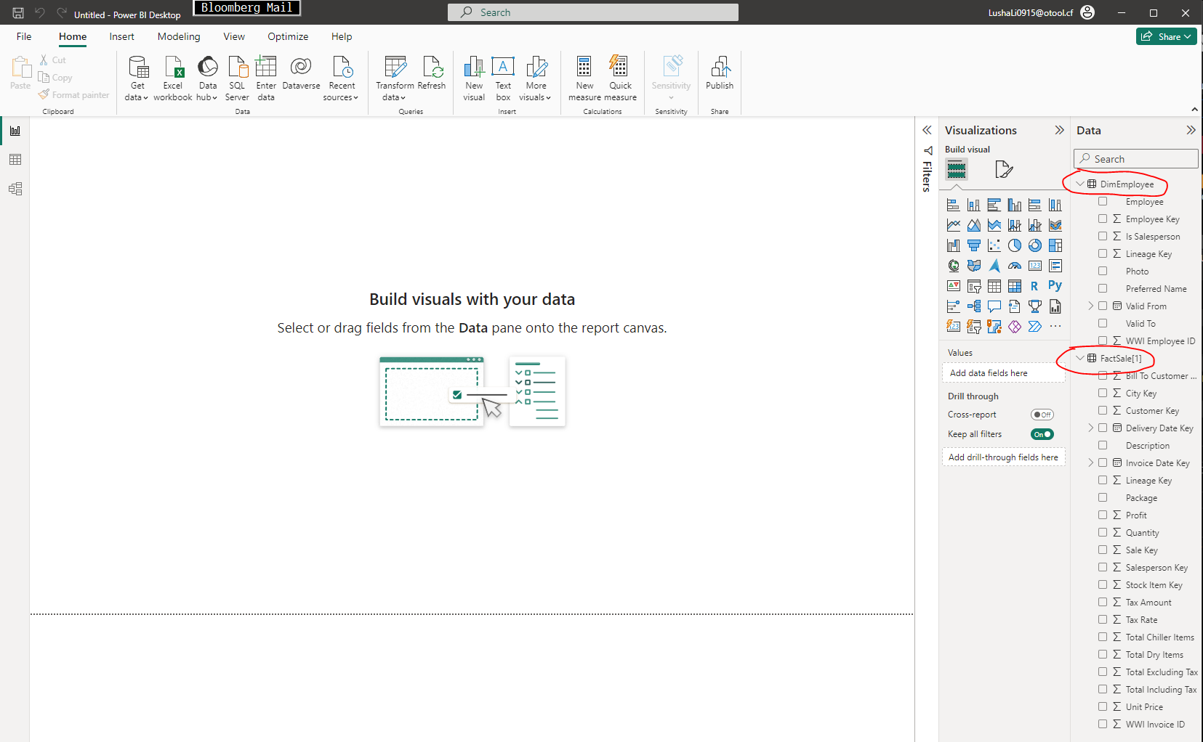

* Slicers在Format那邊可以修改到dropdown的形式

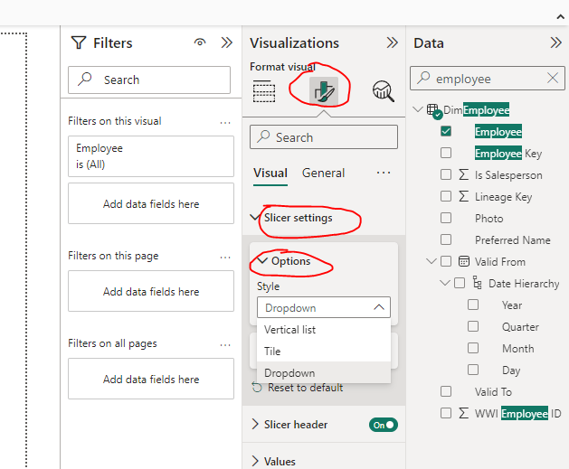

## Transforming data

* Specifically, you will use the Power Query Editor which is a tool that allows you to edit the data prior to loading it. You can use it to format the dataset and decide what gets loaded. The Power Query loads in another screen shown here and uses a language called M. However, you don't need to know M to use it.
* Note that because the Power Query Editor opens in a separate window, you'll need to close it to go back to your report.
* 可以從Power Query Editor裏面undo的記得
* 注意在edit query的時候可以通過這個選項直接把第一行的數據設置爲headers

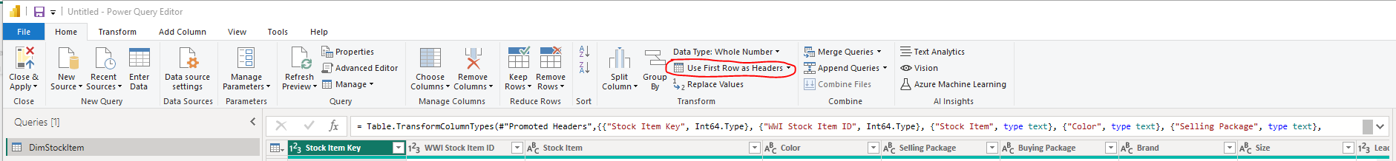

* 在最右邊的Fields pane可以選擇對應的文件名然後右鍵選擇“Edit Query”
* 在Data view裏面有個Column tools（點擊對應的columns之後有）這裏可以修改format

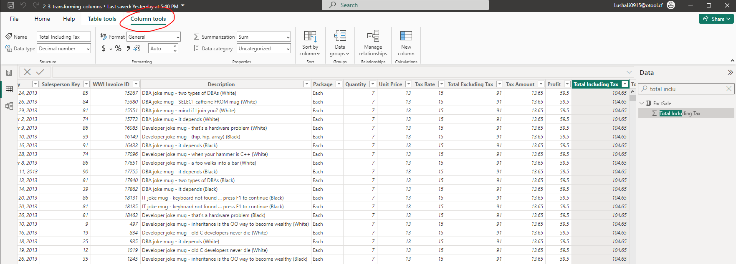

* 左上角三個按鈕對應三個views
* 最上面的是Report view設計報告的
* 中間的Data view編輯數據的
* 最下面的Model view是看關係的

## Visualizing Data

* 如何讓數據根據月份排序而不是他們的英文字母順序排尋 >> Data View >> 點擊對應的列 >> Column tools >> Sort by Column >> MonthNumber

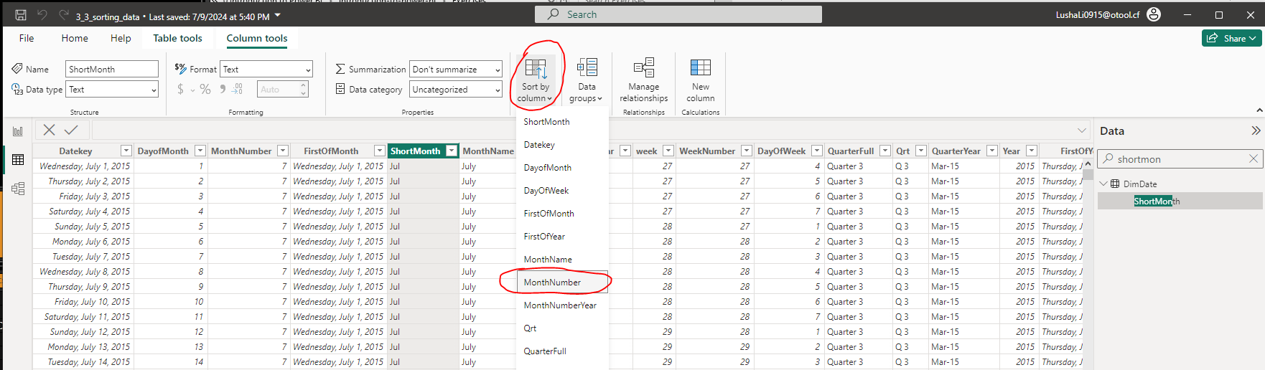

* 然後進一步的按照月份排序展示

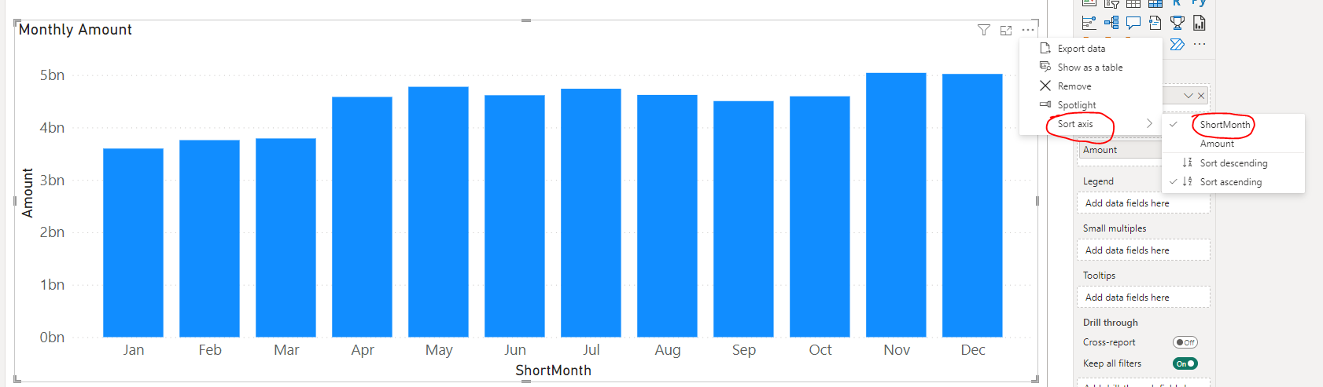

## Filtering

* 在Data View裏面點擊對應欄目的三個點標志可以Create Hierarchies

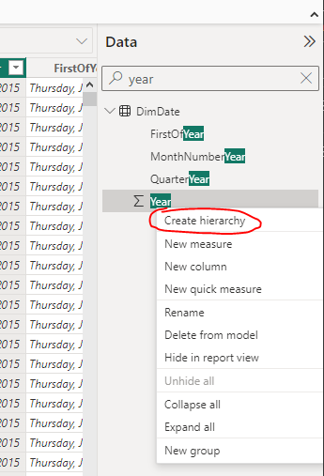

* 在Model View這邊可以選中創建的Hierarchy去修改底層選擇的所有欄目的順序

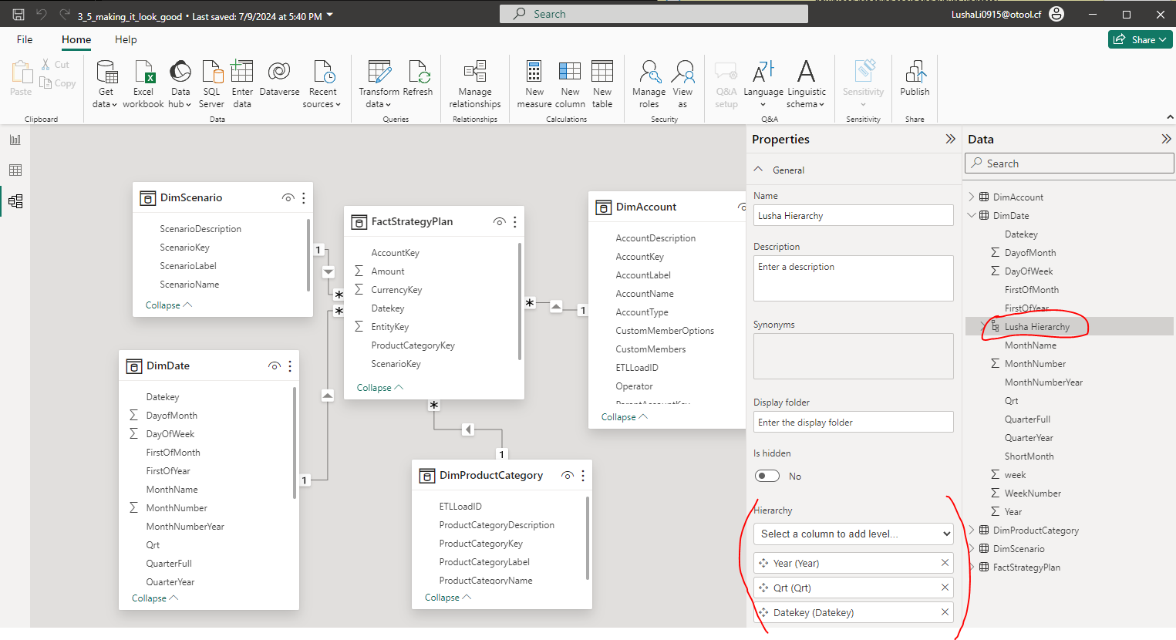

* 加到x-axis之後可以看到右上角多了兩個按鈕，可以點擊去看到不同層次的數據

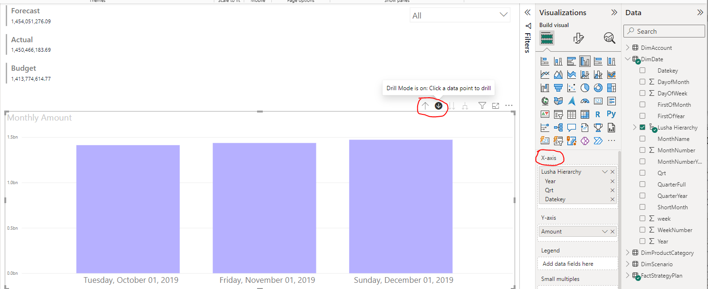

* 右邊有個隱藏的Filters Pane

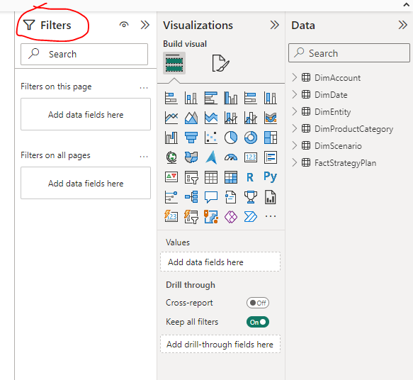

* Format -> Edit interaction可以設置不同visions之間是否互動

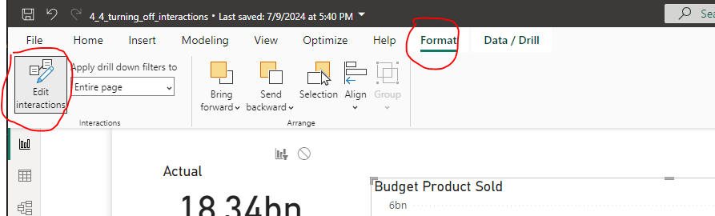

# 24.7.18 Introduction to DAX in Power BI

* DAX stands for Data Analysis Expressions. It is a formula language used in Power BI that provides the ability to create columns, tables, and measures.
* DAX is to Power BI, what formulas are to Excel.
* DAX is more than just Power BI. It is used in other Microsoft tools including Analysis Services and Power Pivot.

## Context in DAX formulas - CALCULATE()

* COUNTAX() is an iterator function
* Filters are optional in the CALCULATE() function
* Row context can apply to calculated columns and measures
* 使用CALCULATE()公式來計算帶有filter的SUM

<https://learn.microsoft.com/en-us/dax/calculate-function-dax>

例子：calculate the sum of line price and filters on the product category “Bikes” and YEAR(Sales[OrderDate]) year being 2018

Measure公式：

2018 Bikes Revenue =

CALCULATE (

   SUM(Sales[LinePrice]),

    Sales[ProductCategory] = "Bikes",

    YEAR ( Sales[OrderDate] ) = 2018

)

## Working with Dates - CALENDAR(), CALENDARAUTO(), DATEDIFF()

* 生成兩個參數日期之間的連續日期表CALENDAR()

<https://learn.microsoft.com/en-us/dax/calendar-function-dax>

Measure公式例子：

Dates =

CALENDAR(

   MIN(Sales[OrderDate]),

   MAX(Sales[OrderDate]),

)

* 生成整個項目文件内最早到最近日期間的連續日期表CALENDARAUTO()
* 只能是1到12之间的整数，默认不填的情况，默认值为12。参数是几，就代表几个月不要了！最多可以不要12个月。
* 它是根据整个项目文件内来寻找最早最晚日期来生成日期表！！！
* 假如你的最大日期是2019年5月1日或者任意一个小于12月31日的日期，那么CALENDARAUTO都会将最大截止日期定为当年的最后一天。
* 假如你的最小日期是2018年5月1日或者任意一个大于1月1日的日期，那么CALENDARAUTO都会将最小日期定为当年的第一天。

<https://learn.microsoft.com/en-us/dax/calendarauto-function-dax>

<https://zhuanlan.zhihu.com/p/98763753>

* 返回两个日期之间的时间DATEDIFF() 函数

<https://learn.microsoft.com/en-us/dax/datediff-function-dax>

* Quick Measure

<https://learn.microsoft.com/en-us/power-bi/transform-model/desktop-quick-measures>

# 24.8.8 Data Visualization in Power BI

1. Dashboard vs “Pixel-Perfect” Report

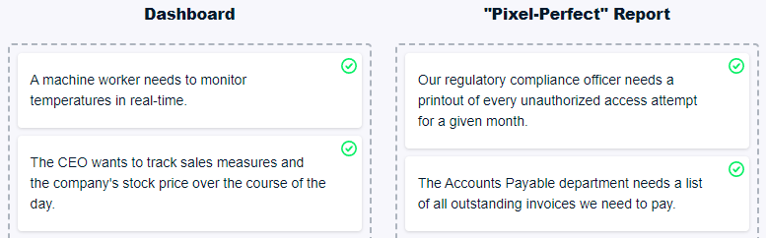

1. Conditional formatting 在中間按鈕裏面fx符號裏面設置

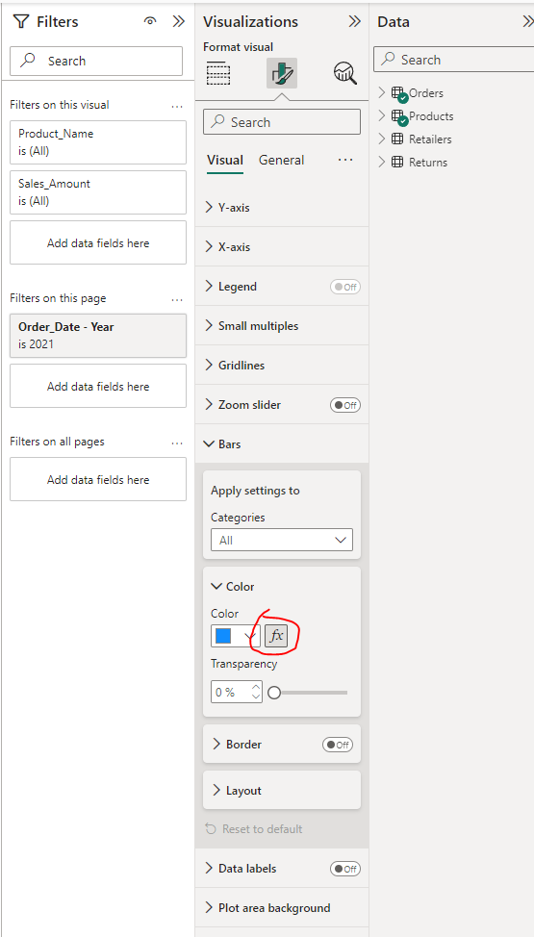

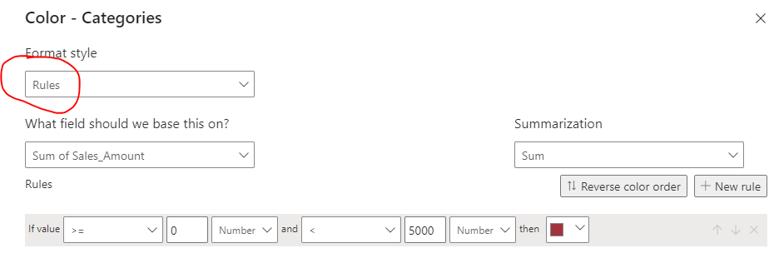

# 24.8.15 Case Study Analyzing Customer Churn in Power BI